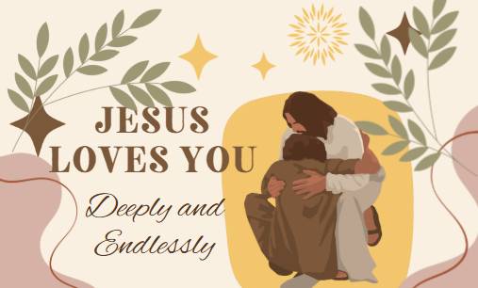

December 28, 2025

This Sunday after Christmas, we did something very different and had a continental breakfast buffet which we ate around tables set up in the sanctuary. We read the following Scripture passage: Matthew 2:13-15, 19-23

Based on this passage, we discussed the following
(written by Rev. Sarah Speed of A Sanctified Art) questions around our tables:

• When you hear the story of the Holy Family fleeing political persecution, how does it make
you feel? Does it make you think of any current or historical events?
• We often skip the story of Herod’s persecution and the Holy Family fleeing to Egypt. Why do
you think that is? What do we lose if we don’t read and know about this text?
• There is so much suffering in the world. What is one organization, non-profit, or grassroots
movement that inspires you?
• Where and how do you see our congregation making a difference in the world? Where can we
grow in this next year and the years to come?
• The scripture of the Holy Family fleeing to Egypt is a story that stirs up compassion for
refugees. When it comes to the work of justice, compassion, and peace, what other causes or
movements are you invested in?
• The theme for this morning is, “Let fear fire a fuel for justice.” How can we move from fear to
action? How do we not let fear stop us in our tracks?

Merry Christmas!

